“A Journey Through the Most Populous Countries of the World in 2022,with R and Shiny Application.”



~ Introduction:

“In this article we are diving into the intricate details of how the world’s 7.9 billion people are distributed across various countries.And also the world’s most populated countries, exploring how these figures shape economic, social, and geopolitical landscapes using “R programming language”.
In 2022, the global population reached unprecedented heights, reflecting significant demographic shifts and highlighting the contrasting population dynamics across different regions.

~ Exploring Data:
First and foremost I downloaded my dataset,prepared and verified it. I ensured that this dataset was accurate, trustworthy, and ready for in-depth analysis.
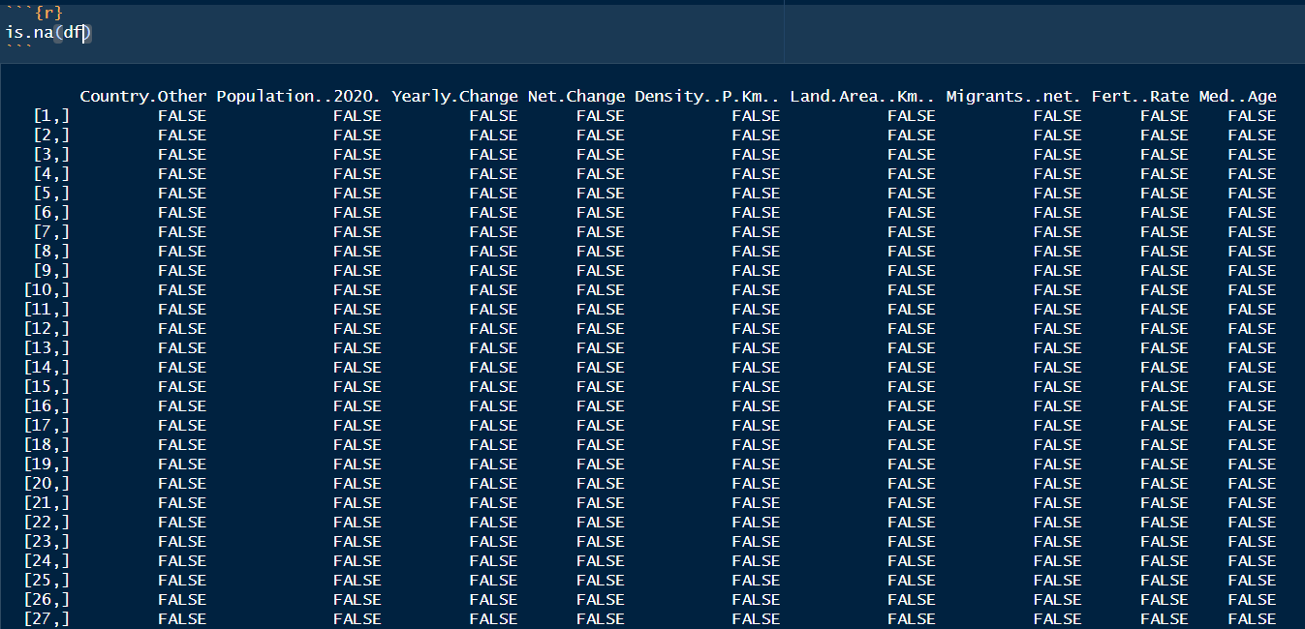
This allowed me to generate meaningful insights into the population dynamics of the world’s most populated countries in 2022, and then imported the data set into the “R programme”
While Analysing this data set “Population by Country”,reveals several interesting insights about global population distribution and trends:
- China and India together account for a significant portion of the world’s population(They alone comprise about 36% of the global population)
2.Rapid Growth in Africa:Several African nations are experiencing rapid population growth(countries like Ethiopia, Egypt, and the Democratic Republic of Congo shows significant population increases.)
3.Declining Populations in Some countries (countries like Russia and Ukraine are witnessing population declines.)
These insights shows the importance of these data in different aspects of economic,political,geographical matters across the world. Understanding these trends are very important.
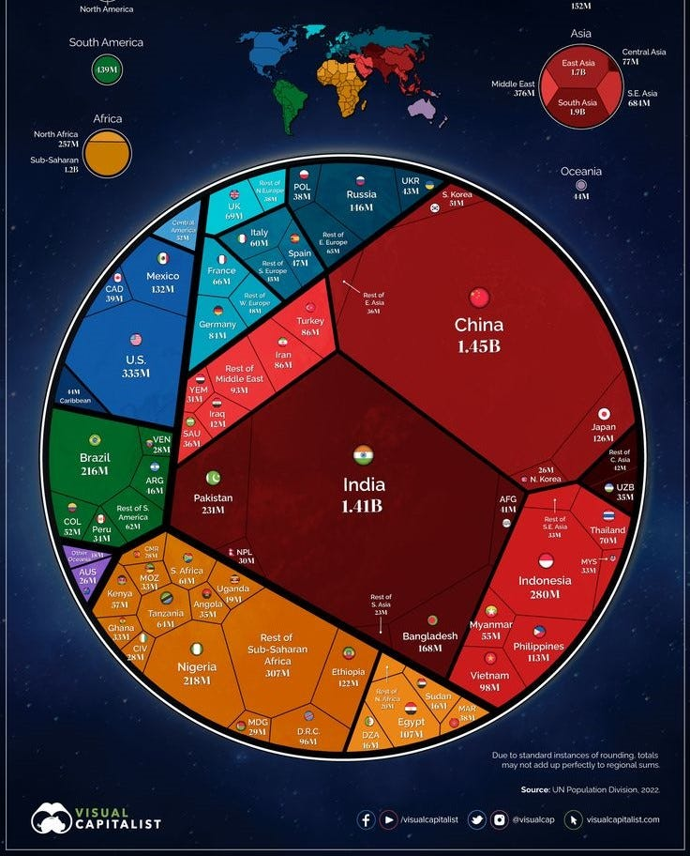

~ Working with R Shiny:
Shiny is an R package that enables building interactive web applications that can execute R code on the back end. With Shiny, you can ,
- Host standalone applications on a web page,.
- Embed interactive charts in R Markdown documents.
- Build dashboards.
so to start off I opened a shiny package and started to type the coding required to get the “scatter plot” and “Histogram” for the selected country.
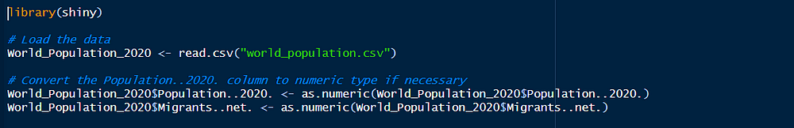
defining server logic creating the backed functionality for an R Shiny web application,
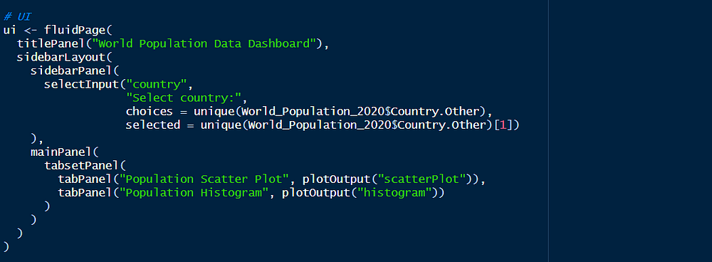
this gave me a visual representation of the selected fields,in this case Population and Migrants.
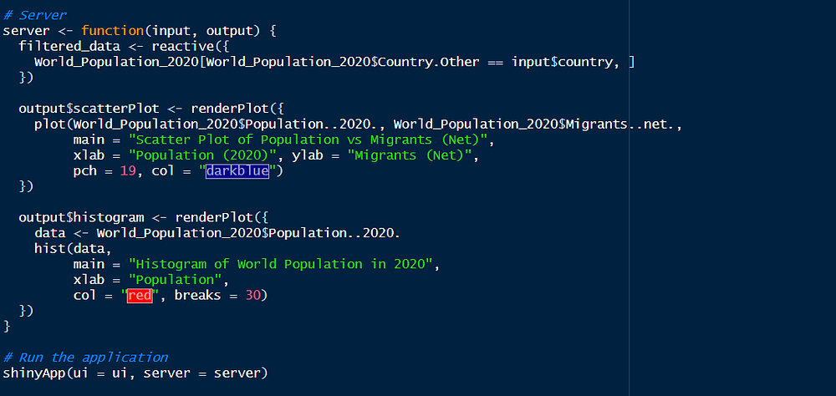
After running this coding I got a app page with the boxes of population Histogram and population Scatter plot plus a another box with the option of choosing the county I wanted,
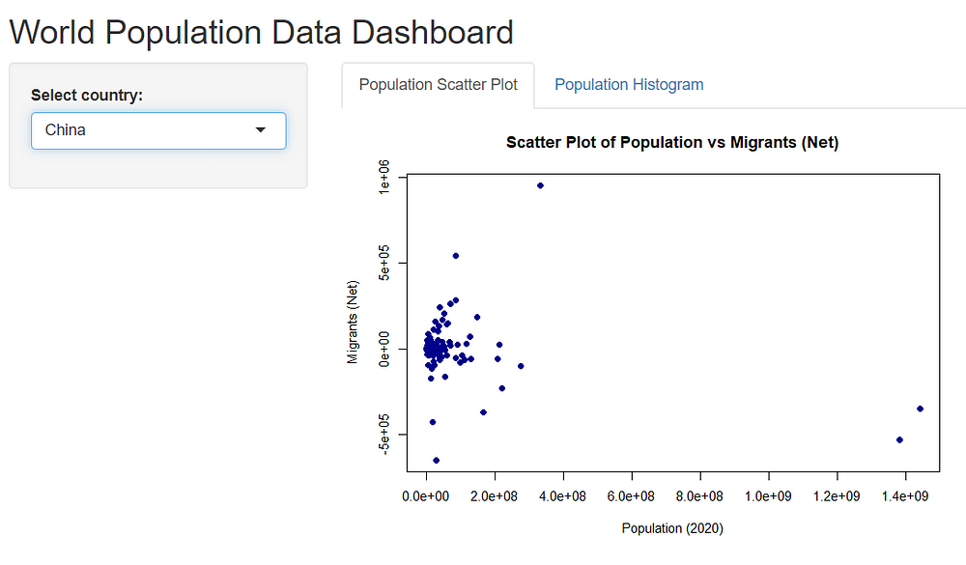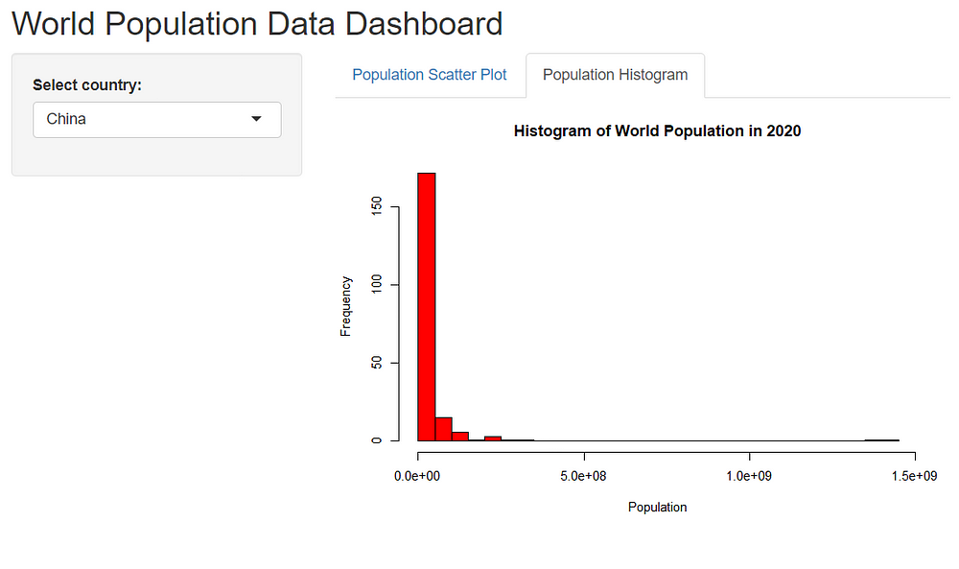
As we can see the above Histogram and scatter plot shows the relationship between Population and migrants in china in 2022.And as china we can look in to all the 201 counties present in the world in 2022.

~ Seeing Patterns:
Lets focus on some of the columns in the data set “World Population 2022”.There are some interesting patterns and insights in this data set.
- we can see that the most populated counties are china,India and USA.With the combined population being around 1.8billion
- The smaller the land area(K.M) the Dencity of the population also rises.shown in the plot below,
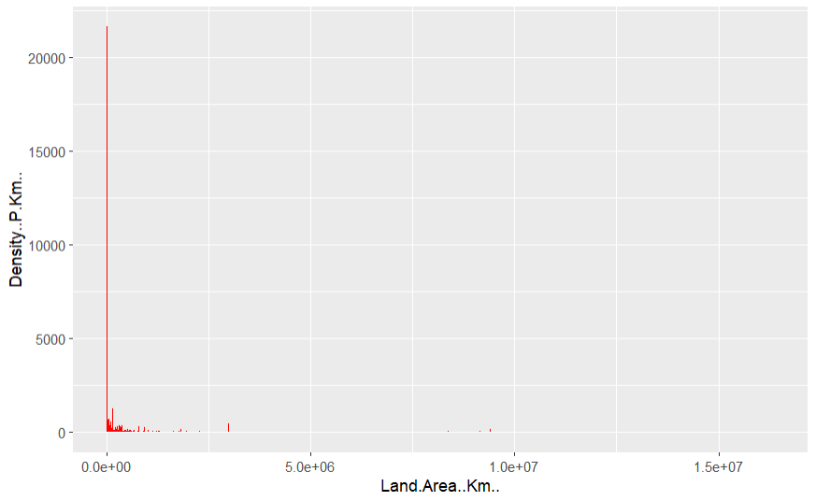
3. when it comes to population,higher the population number the higher the Migrant numbers as well.shown down below,
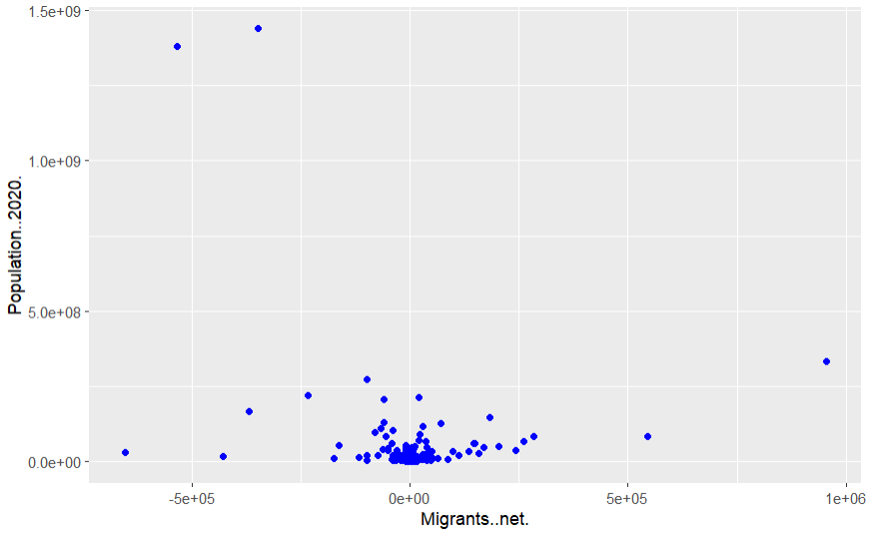
4.Net Change: Population changes range from a decrease of 383,840 to an increase of 13,586,630.
5.Density: Population density changes heavily, with a minimum of 2 and a max of 21,645 people per square kilometer.
as you can see these are few of the patterns and connections that stand out of this dataset alone with others.
these patterns and connections have huge impacts in economic development,social services, and global geopolitics.Understanding these and studying these will help counties in policy making, businesses and various organisations serving on international cooperation. and this shows the importance of the following data…
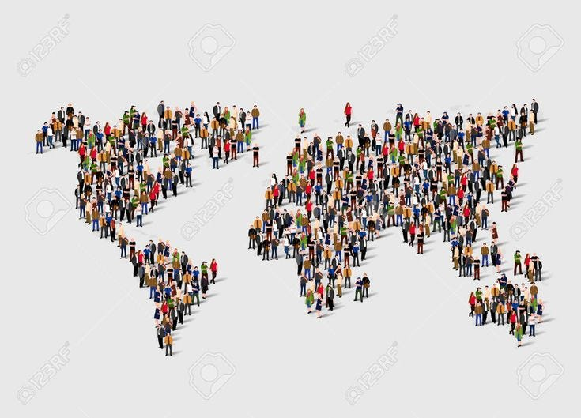

~ Making Predictions:
I used a linear regression model to predict population of 2020 based on world shares. This model helps us understand the relationship between these two variables and make informed predictions.It uses a straight line to describe the relationship between two variables.
the linear regression analysis model is as follows,
code for the linear regression model.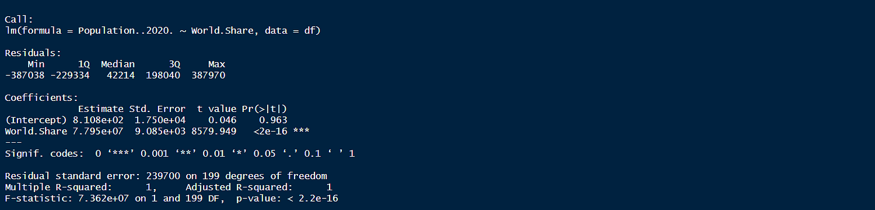output from the linear regression analysis.

from this regression analysis we can predict the following,
· Min: -387038
· max: 387970
· 1Q (1st Quartile): -229334
· Median: 42214

From the output:
- Intercept (𝛽0β0​): 810.8(The intercept (810.8) is not significantly different from zero (p-value = 0.963). This suggests that when the world share is zero, the population is not significantly different from zero, which makes sense in this context.)
- Coefficient for World.Share (𝛽1β1​): 77,950,000(the coefficient for World.Share is 77,950,000, which is highly significant (p-value < 2e-16). This means for every unit increase in the world share, the population increases by approximately 77,950,000.)
- Adjusted R-squared : Approximately 100% of the variants in population is explained by world share.(The R-squared value is 1, indicating that the model explains 100% of the variability in the population data. This is an indication of a perfect fit, which can sometimes be a sign of overfitting or that the independent variable is perfectly correlated with the dependent variable.)
These predictions can help different countries understand how changes in the “World.Share” percentage impact the Population in 2020 according to the linear regression model above.

~ Putting It All Together:
To combine my predictions with the graphs I ,
· Analysed the data to understand the current population trends.(by examining the basic statistics and distributions of the dataset to get a sense of the data)
· Made predictions using the Linear regression analysis.(using the current population stats to predict the future population stats)
· Visualised the data using and creating graphs to illustrate both the current data and the predictions.
This successfully combines data analysis, predictions, and visualizations to reveal trends in world population, making complex information accessible and understandable.

From this analysis i discovered,
Current Population Distribution,Yearly Population Change, Predicted Population Growth ,Visualisation Insights….These stats help in understanding global population trends and the impact of growth rates on future demographics.
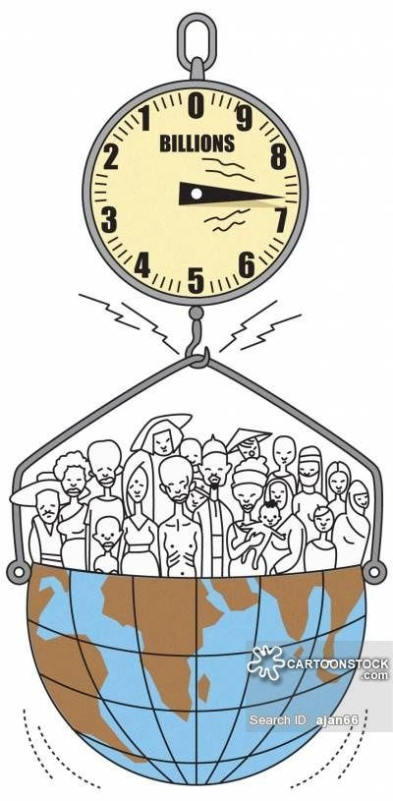

~ Conclusion:
As we’re nearing our data analysis journey lets take a look at what we learned and discovered. In this article we discovered different stats and patterns and various info about the world’s population.
we cleaned,and made ready the dataset ,created interactive visualisation graphs using R shiny, and used Linear regression analysis to analyse the data set.identified key patterns.
By this journey I gained a wast amount of information and knowledge about the world population in 2022.More importantly we saw the capabilities and power of R in data analysis and predicting.
last but not least ,If you’re interested and curious about diving deeper into data analysis and visualisation, I encourage you to get a dataset of your own and try it out on “R”.

thank you!


